**L&T project**

**Title:**

Automated Dustbin system

**Problem statement:**

Develop a simple Ardunio UNO-based Automatic dust Bin system which can open the lid when it senses the object movement nearby.

**Scope of the solution:**

The core objective of the **Arduino Smart Dustbin** is to detect the presence and open the dustbin, later after the trash is put we have to close it. In a previous project , we used a Ultrasonic sensor that could spot objects, and when it did, the robot changed its route to follow the object (our human). In our **Smart Dustbin Arduino project**, we there doing something similar. We have put Ultrasonic sensor on top of the dustbin's cover. So, when the sensor sees something like a person's hand, it tells the Arduino to open the lid.

**Required components to develop solution:**

1 x Arduino Uno

1 x Ultrasonic sensor

Jumper wires

1 x Breadboard

1x Servo motor

**Simulated circuit:**

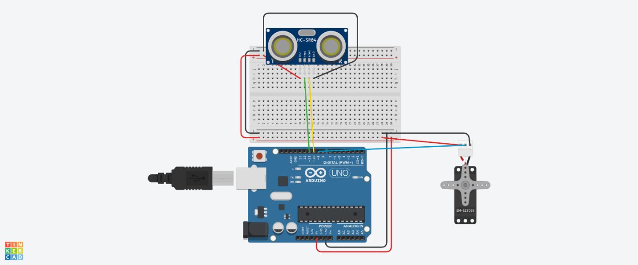

**Gerber File:**

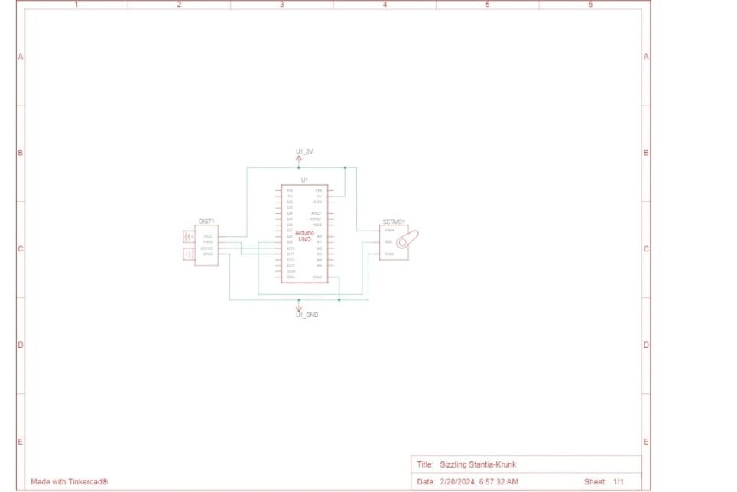

**Code for the solution:**

// C++ code

// C++ code

//

#include <Servo.h>

Servo myServo;

#define trigPin 11 // Trig pin of the ultrasonic sensor connected to digital pin 9

#define echoPin 10 // Echo pin of the ultrasonic sensor connected to digital pin 10

void setup() {

Serial.begin(9600);

pinMode(trigPin, OUTPUT);

pinMode(echoPin, INPUT);

myServo.attach(9); // Attach the servo to digital pin 9

}

void loop(){

long duration, distance;

// Trigger the ultrasonic sensor by sending a 10μs pulse

digitalWrite(trigPin, LOW);

delayMicroseconds(2);

digitalWrite(trigPin, HIGH);

delayMicroseconds(10);

digitalWrite(trigPin, LOW);

// Measure the pulse duration on the echo pin

duration = pulseIn(echoPin, HIGH);

// Calculate the distance based on the speed of sound (343 meters/second or 0.0343 cm/microsecond)

distance = duration * 0.0343 / 2;

// Print the distance to the Serial Monitor

Serial.print("Distance: ");

Serial.print(distance);

Serial.println(" cm");

delay(1000); // Adjust the delay time based on your application

if(distance <= 20)

{

for (int angle = 0; angle <= 180; angle += 1) {

myServo.write(90);

delay(15); // Adjust the delay for smoother movement

}

}

else

{

for (int angle = 90; angle >= 0; angle -= 1) {

myServo.write(0);

delay(10); // Adjust the delay for smoother movement

}

// digitalWrite(Buzzer,LOW);

}

}